**NFS server Assessment**

**Objective:**

Set up and configure an NFS server for file sharing, including installation, service management, directory setup, permission configuration, client setup, and firewall adjustments.

**Installs the necessary packages for running an NFS server.**

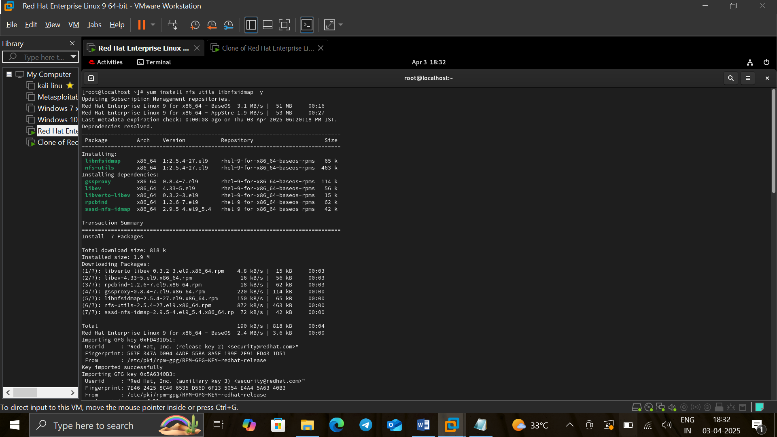

**Enable and Start Services**

* Enables and starts essential services for NFS operation, including rpcbind, nfs-server, and others.

**systemctl enable rpcbind nfs-server.service**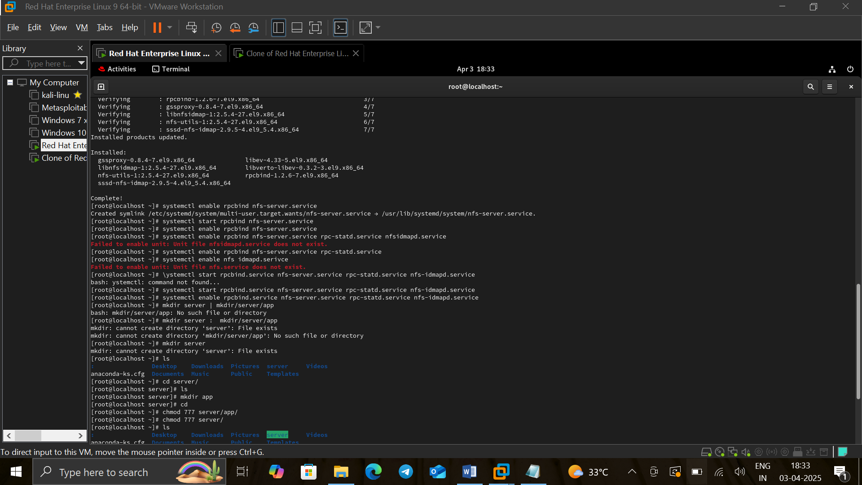

**systemctl start rpcbind.service nfs-server.service rpc-statd.service nfs-idmapd.service**



**Create Shared Directory**

* Creates the /server/app directory and sets permissions to allow full access.

**mkdir -p /server/app**



**chmod 777 /server**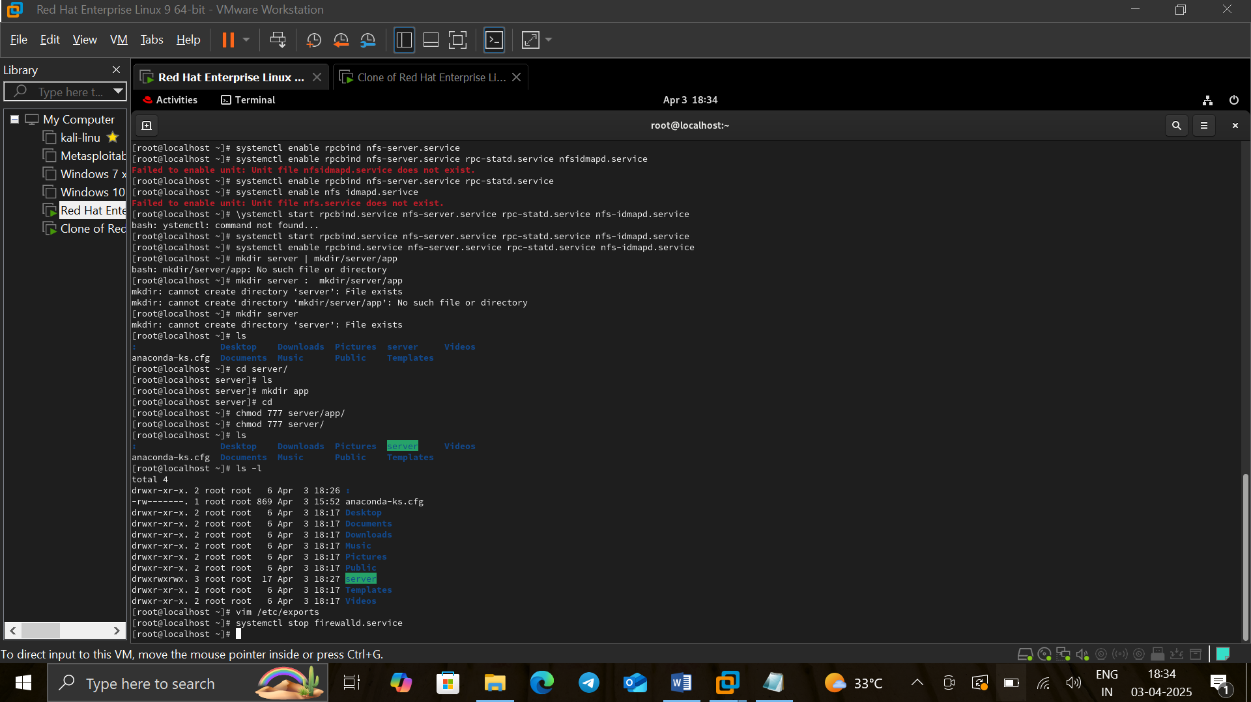

**chmod 777 /server/app**



**Configure NFS Exports**

* Opens the NFS export configuration file to specify the shared directory.

**vim /etc/exports**

Shares /server/app **with all clients** (*)**, allowing read-write access.**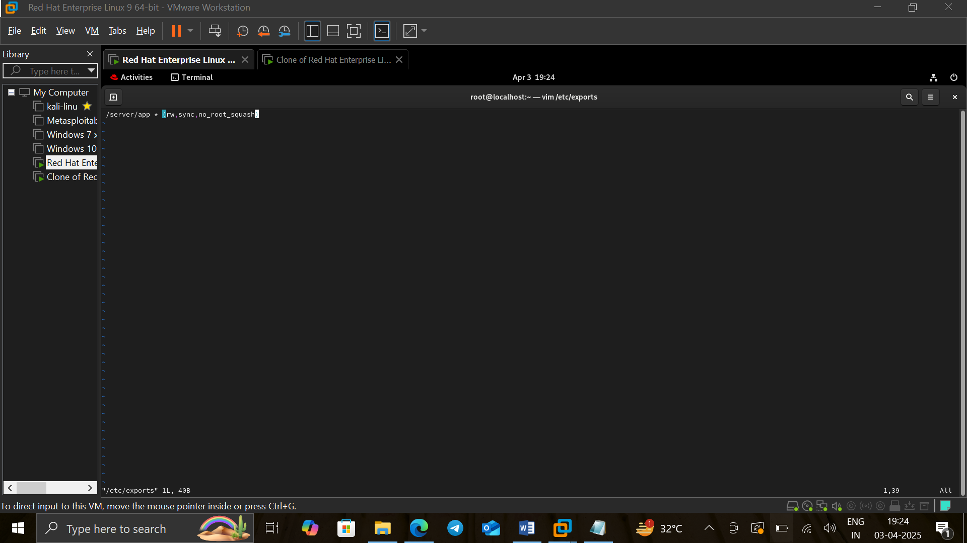

**Stops the firewall service, which may be necessary for connectivity.**

**NFS Client Setup:**

**Installs** NFSutilities **and** rpcbind **on the client.**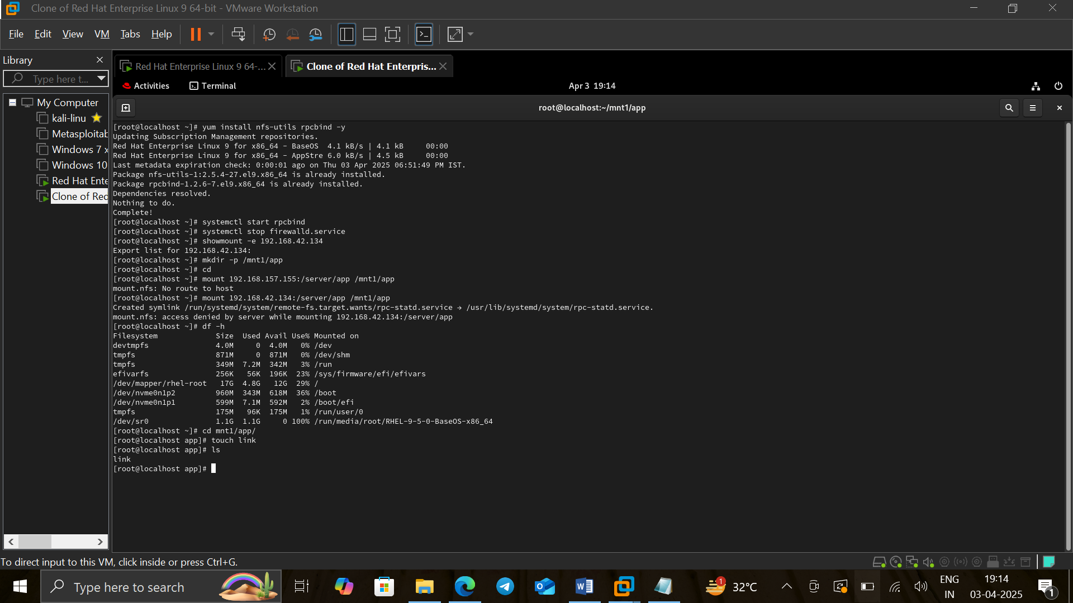

**Starts the** rpcbind **service, which helps with network communication.**



**Disable Firewall** (Again, not secure in production)

**Creates a local directory to mount the NFS share. Lists available NFS shares from the server at 192.168.157.155.**

**Mounts the remote NFS share at** /mnt1/**app.**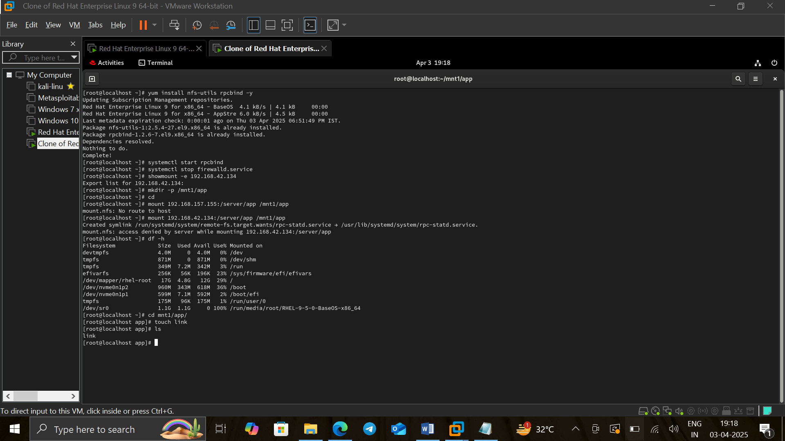

**Displays disk space usage to confirm that the NFS share is mounted.**